
2011 Hunting Season . 4th Newsletter

Dear All

With our Xmas dinner tomorrow night it is a sure sign that the season has finally ended. It was hugely successful and exciting season for CMS. Not only in the fanatasic trophies that were shot throughout the year but also for the fact that CMS has secured two more areas, namely Hammond in the Save and Chiwalo in Mozambique . These two areas compliment the Dande and Makuti perfectly. This has given CMS clients a full range of options for the finest hunting in Zimbabwe and outstanding croc and hippo in Mozambique.

Hammond – Our new area in the Save is Hammond Ranch and boasts the best buffalo hunting in the country with trophy expectations been in the 40s and a chance of a mid to high 40” if you are lucky! It has excellent plains game hunting and a 5 star camp to compliment this beautiful area.

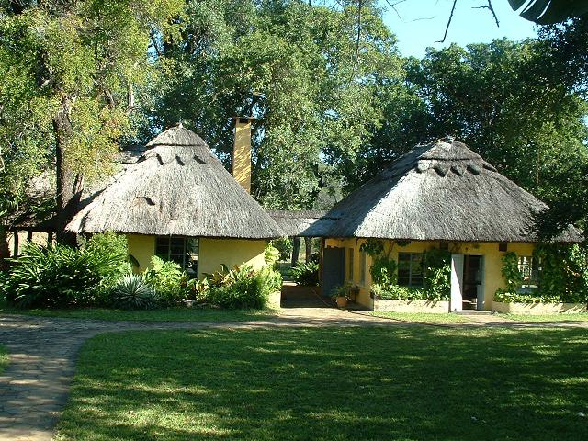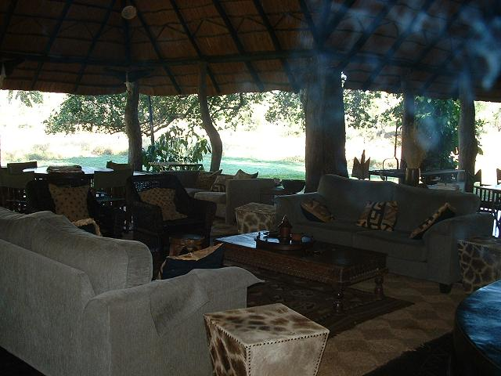

Hammond Camp in the Save Valley Conservancy

Chiwalo- which is our new area in Mozambique has undoubtedly the best croc and hippo hunting available today. We have done several very successful hunts a season there for the last few years and what is nice is that it is so close to Dande that a combined Dande/Mozambique hunt is very easy to organise and compliment each other very well indeed.

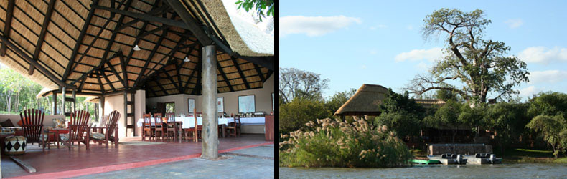

Chiwalo Camp – Mozambique

THE HUNTING 2011

The early part of the season was very wet and hard but the ele hunting was excellent and we shot our full quota of good elephant bulls in the East as well as the Dande Safari area. Once again we averaged the highest in the Zambezi Valley and with the opening of new roads in the East area 2012 promises to be even better!!

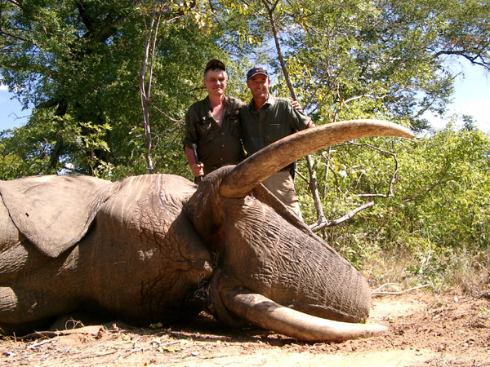
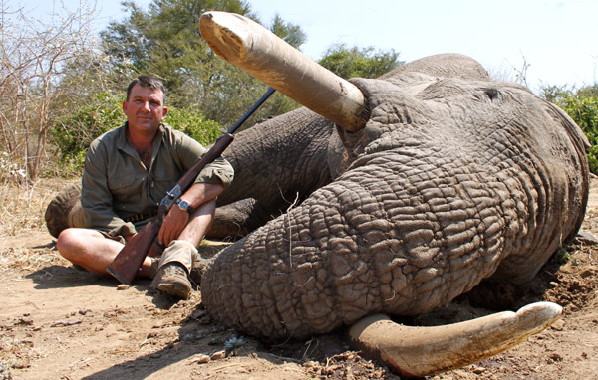
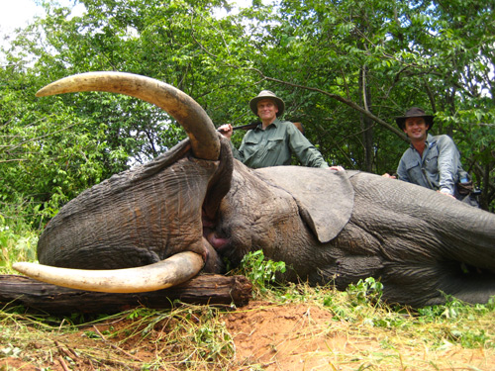

Vladimir Gubarev, Scott Brown & Marty Vick with their elephant bulls

The buffalo hunting early season proved to be very challenging however from mid season on and in particular late season was excellent and both Dande and Makuti produced some out standing buffalo. We were 100% on our success rate and we are happy to report that late this season we have seen good numbers of calves which bodes well for the future buff hunters!
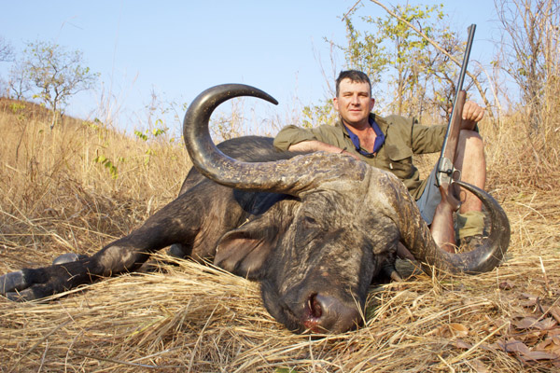
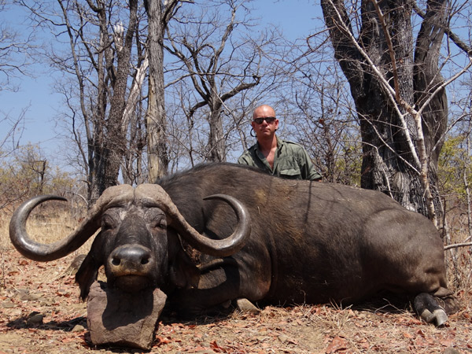
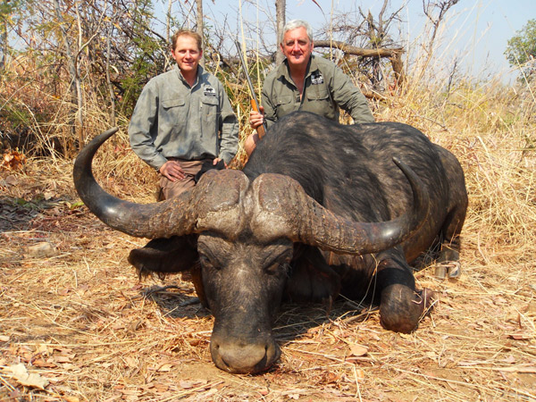

Scott Brown, Mike Wittet & Brett Barnes with their buffalo bulls

The cat hunting was as a whole also very good with Lions been numerous and pretty easy. We filled our lion quota of 3 with ease and got 3 really good valley cats as seen below. Two were shot on bait and Robs lion was tracked for 8 hours before been shot on an elephant carcass we found him eating on which was an outstanding hunt!

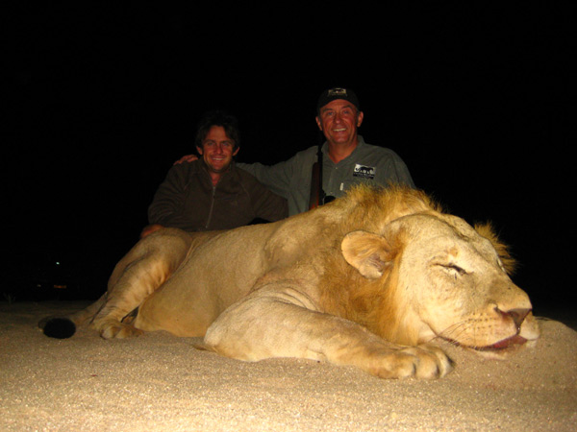
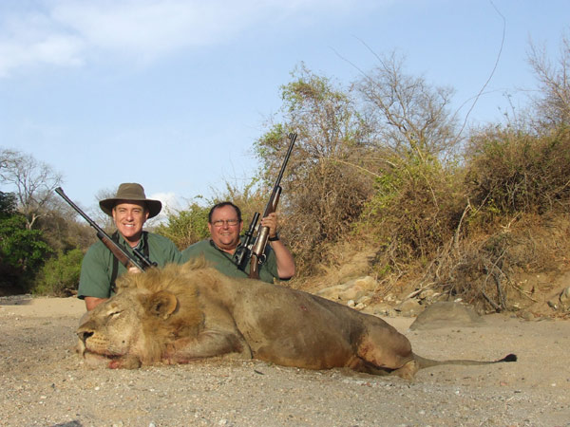
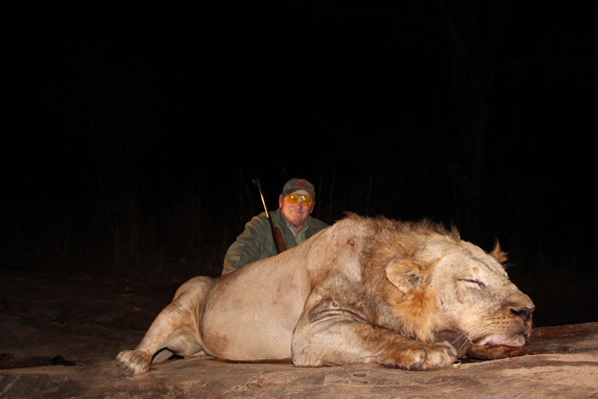

Robert Jolly, Mike Tenny, Bart Rasmussen with their lion
The leopards proved to be slightly more difficult this year as they were countrywide and for the very first year we were not 100% successful. We filled our quota of 3 magnificent cats in Makuti and we shot 4 out of the 5 in the Dande- still a very good and healthy average for leopard hunting by any standards in Africa!

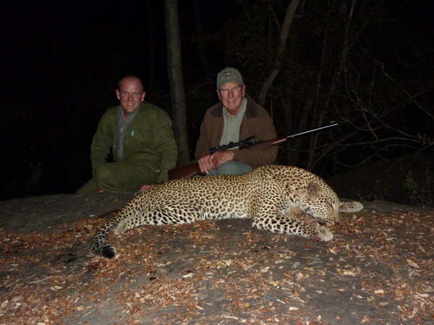
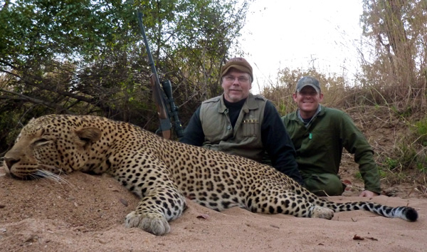
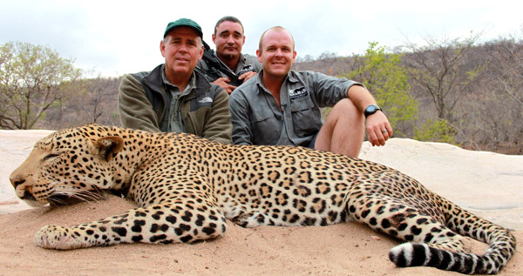

Jerome Haner, Casey Terry & Todd Williams with their leopard

Other outstanding trophies were a 45 ‘ sable shot by Lorinda, a 61” Kudu shot by Bill and “BORIS” the mounted Hyena shot by numerous !!!!!!

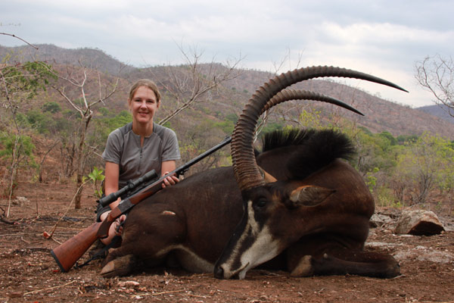
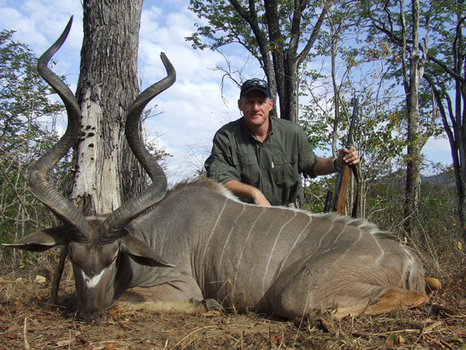

Lorinda van der Reyden & Bill Clayton

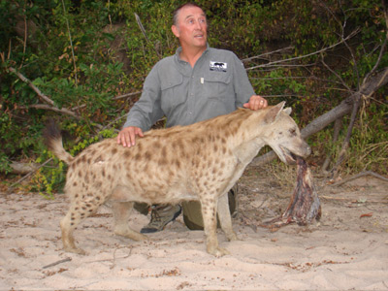
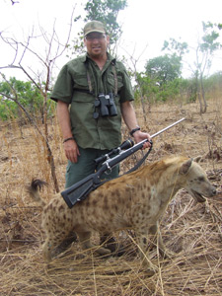

Robert Jolly & Jerry Nave with Boris

Finally it is to say thanks to all you valued clients/ friends for supporting our little company and we look forward to sharing the campfire with you all again in the near future. HAPPY CHRISTMAS and New Year - All the best - CMS staff

